
Faculty of Science

Course: CSCI 2020u – Software System Development & Integration
Component: Assignment
Weight: 10%
Deadline: March 5, 2020 (due by 11:59pm)

Collaboration Policy
You are permitted to work on this assignment in a team, and submit the results as a team. For this sort of assignment, with an open-ended component, the collaboration between multiple team members can be beneficial. Between groups, however, please limit the discussion to the level of general strategy (not code). Groups of size 2 are recommended. Larger groups will be considered with the proviso that the marker will mark your assignment with higher expectations. In any case, be sure that all members of the team fully understand all code, otherwise they will miss intended learning objectives, which may be a considerable disadvantage at exam time.

How to Submit
You will maintain a git repository for this assignment, which is a public repository. To submit the assignment, create a single file ‘README.txt’ that contains instructions on how to download, compile, and run your codes for each question. A .zip, .7z, or .rar file will not be acceptable. Also submit this word file (once you complete) into related drop box on Blackboard before deadline.

Note: Comments are mandatory. Failure to properly document your program will result in a deduction on the marks you receive for this (and any other) assignment.

Remember:
You need to complete this file and submit it in related drop box on Blackboard, in addition to uploading your codes in your git repository, before deadline.

Question 1: Displaying Three Cards

Problem Description:
Display a frame that contains three labels. Each label displays a card, as shown in the figure below. The card image files are named 1.png, 2.png, ..., 54.png and stored in the image/card directory. All three cards are distinct and selected randomly.

The image icons can be found in the attached card folder.

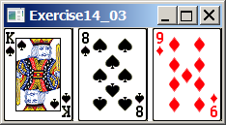

Your Task:
- Create three ImageView and set their icons using the images.
- Display three images from 54 image cards randomly.

Your Code: Copy-paste your code here:
package sample;
import javafx.application.Application;
import javafx.scene.Scene;
import javafx.scene.image.Image;
import javafx.scene.image.ImageView;
import javafx.scene.layout.GridPane;
import javafx.stage.Stage;
import java.util.Random;
public class Main extends Application {
@Override
public void start(Stage primaryStage) throws Exception{
primaryStage.setTitle("Question 1");
GridPane layout = new GridPane();
Image[] images = new Image[58];
for(int i = 1; i <= 54; i++){
images[i] = new Image("file:images/" + i + ".png");
}
images[54] = new Image("file:images/b1fh.png");
images[55] = new Image("file:images/b2fh.png");
images[56] = new Image("file:images/b1fv.png");
images[57] = new Image("file:images/backCard,png");
Random rand = new Random();
layout.add(new ImageView(images[rand.nextInt(55) + 1]), 0, 0);
layout.add(new ImageView(images[rand.nextInt(55) + 1]), 1, 0);
layout.add(new ImageView(images[rand.nextInt(55) + 1]), 2, 0);
Scene scene = new Scene(layout, 500, 500);
primaryStage.setScene(scene);
primaryStage.show();
}
public static void main(String[] args) {
launch(args);
}
}
Screen shots: Include two screen shots here:
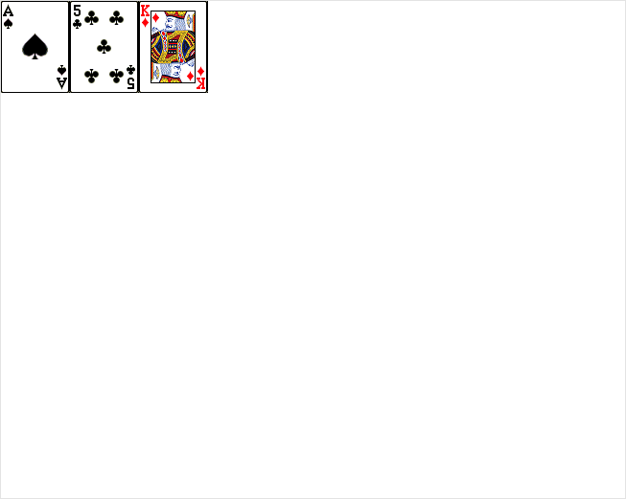

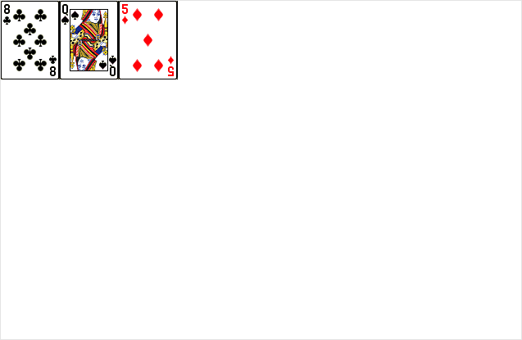
Question 2: Investment-Value calculator

Problem Description:
Write a program that calculates the future value of an investment at a given interest rate for a specified number of years. The formula for the calculation is as follows:

futureValue = investmentAmount * (1 + monthlyInterestRate)years*12

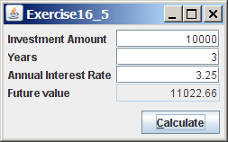

Your Task:
Use text fields for interest rate, investment amount, and years. Display the future amount in a text field when the user clicks the Calculate button, as shown in the figure.

Your Code: Copy-paste your code here.
package sample;
import javafx.application.Application;
import javafx.geometry.Pos;
import javafx.scene.Scene;
import javafx.scene.control.Button;
import javafx.scene.control.ContentDisplay;
import javafx.scene.control.Label;
import javafx.scene.control.TextField;
import javafx.scene.layout.GridPane;
import javafx.scene.layout.HBox;
import javafx.stage.Stage;
import javax.swing.*;
public class Main extends Application {
@Override
public void start(Stage primaryStage) throws Exception{
primaryStage.setTitle("Question 2");
//Root layout
GridPane layout = new GridPane();
//Text fields for all inputs & calculate button
TextField investmentAmount = new TextField();
TextField years = new TextField();
TextField annualInterest = new TextField();
TextField futureValue = new TextField();
Button calculateButton = new Button("Calculate");
//Set the position of all items
layout.add(new Label("Investment Amount"), 0, 0);
layout.add(investmentAmount, 1, 0);
layout.add(new Label("Years"), 0, 1);
layout.add(years, 1, 1);
layout.add(new Label("Annual Interest Rate"), 0, 2);
layout.add(annualInterest, 1, 2);
layout.add(new Label("Future Value"), 0, 3);
layout.add(futureValue, 1, 3);
layout.add(calculateButton, 1, 4);
//Set on click action to calculate values for future value and display it
calculateButton.setOnMouseClicked((event) -> {
double investmentAmountInt = Double.parseDouble(investmentAmount.getText());
double monthlyInterestRate = Double.parseDouble(annualInterest.getText())/12;
double futureValueInt = investmentAmountInt * Math.pow((1 + monthlyInterestRate),
(Double.parseDouble(years.getText())*12));
long answer = Math.round(futureValueInt);
futureValue.setText(Long.toString(answer));
});
Scene scene = new Scene(layout, 800, 800);
primaryStage.setScene(scene);
primaryStage.show();
}
public static void main(String[] args) {
launch(args);
}
}
Screen shots: Include two screen shots here:
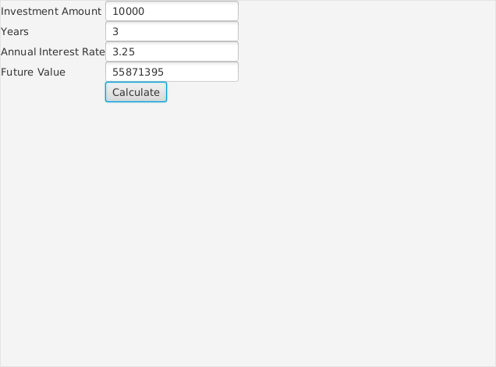
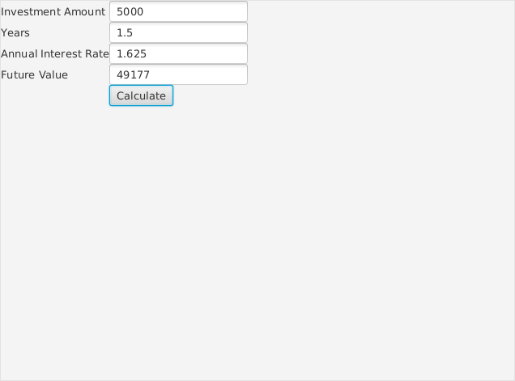

Question 3: Dragging Points on a Circle

Problem Description:
Draw a circle with three random points on the circle. Connect the points to form a triangle. Display the angles in the triangle. Use the mouse to drag a point along the perimeter of the circle. As you drag it, the triangle and angles are redisplayed dynamically.

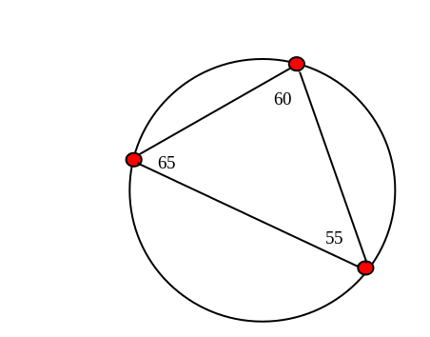

Here is the formula to compute angles:

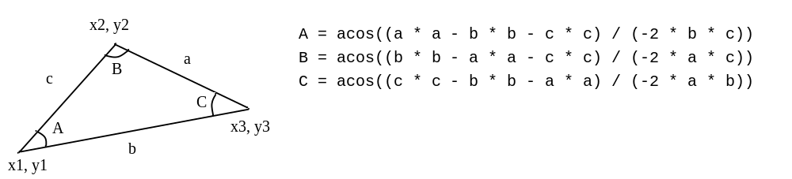

Your Code: Copy-paste your code here:
package sample;
import java.util.Random;
import javafx.stage.Stage;
import javafx.application.Application;
import javafx.geometry.Point2D;
import javafx.scene.Group;
import javafx.scene.Scene;
import javafx.scene.paint.Color;
import javafx.scene.shape.Circle;
import javafx.scene.shape.Line;
import javafx.scene.text.Text;
public class Main extends Application {
//Generate three random points on the circle
Random rand = new Random();
int random1 = rand.nextInt(360) + 1;
int random2 = rand.nextInt(360) + 1;
int random3 = rand.nextInt(360) + 1;
//Create three circles for points
Circle point1 = new Circle();
Circle point2 = new Circle();
Circle point3 = new Circle();
//Create three lines to connect each point
Line line1 = new Line();
Line line2 = new Line();
Line line3 = new Line();
//Create the text for angles displayed
Text textA = new Text();
Text textB = new Text();
Text textC = new Text();
@Override
public void start(Stage primaryStage) throws Exception{
//Root layout
Group root = new Group();
root.minWidth(650);
root.minHeight(480);
//Create the main circle
Circle circle = new Circle();
circle.setRadius(150);
circle.setCenterX(320);
circle.setCenterY(240);
circle.setStroke(Color.BLACK);
circle.setFill(Color.WHITE);
//Create the three random points with random x & y values constrained to the main circle
point1.setRadius(5);
point1.setFill(Color.RED);
point1.setCenterX(circle.getCenterX() + circle.getRadius() * Math.cos(random1 * Math.PI / 180F));
point1.setCenterY(circle.getCenterY() + circle.getRadius() * Math.sin(random1 * Math.PI / 180F));
point2.setRadius(5);
point2.setFill(Color.RED);
point2.setCenterX(circle.getCenterX() + circle.getRadius() * Math.cos(random2 * Math.PI / 180F));
point2.setCenterY(circle.getCenterY() + circle.getRadius() * Math.sin(random2 * Math.PI / 180F));
point3.setRadius(5);
point3.setFill(Color.RED);
point3.setCenterX(circle.getCenterX() + circle.getRadius() * Math.cos(random3 * Math.PI / 180F));
point3.setCenterY(circle.getCenterY() + circle.getRadius() * Math.sin(random3 * Math.PI / 180F));
root.getChildren().addAll(circle, point1, point2, point3, line1, line2, line3, textA, textB, textC);
//Draw the connecting lines and calculate the original angles
draw(root, circle);
//Set the action on mouse drag to update the points position
point1.setOnMouseDragged(e -> {
point1.setCenterX(e.getX());
point1.setCenterY(e.getY());
//Update the lines drawn along with the angles
draw(root, circle);
});
//Set the action on mouse drag to update the points position
point2.setOnMouseDragged(e -> {
point2.setCenterX(e.getX());
point2.setCenterY(e.getY());
//Update the lines drawn along with the angles
draw(root, circle);
});
//Set the action on mouse drag to update the points position
point3.setOnMouseDragged(e -> {
point3.setCenterX(e.getX());
point3.setCenterY(e.getY());
//Update the lines drawn along with the angles
draw(root, circle);
});
Scene scene = new Scene(root);
primaryStage.setTitle("Question 3");
primaryStage.setScene(scene);
primaryStage.show();
}
public void draw(Group pane, Circle circle) {
//Set the starting and ending points of each line based on the existing points
line1.setStartY(point1.getCenterY());
line1.setStartX(point1.getCenterX());
line1.setEndY(point2.getCenterY());
line1.setEndX(point2.getCenterX());
line2.setStartX(point2.getCenterX());
line2.setStartY(point2.getCenterY());
line2.setEndX(point3.getCenterX());
line2.setEndY(point3.getCenterY());
line3.setStartX(point3.getCenterX());
line3.setStartY(point3.getCenterY());
line3.setEndX(point1.getCenterX());
line3.setEndY(point1.getCenterY());
//Get the length of each line
double a = new Point2D(point2.getCenterX(), point2.getCenterY()).distance(point3.getCenterX(),
point3.getCenterY());
double b = new Point2D(point1.getCenterX(), point1.getCenterY()).distance(point3.getCenterX(),
point3.getCenterY());
double c = new Point2D(point1.getCenterX(), point1.getCenterY()).distance(point2.getCenterX(),
point2.getCenterY());
//Calculate the angle based on the lengths
double angleA = Math.acos((a * a - b * b - c * c) / (-2 * b * c));
double angleB = Math.acos((b * b - a * a - c * c) / (-2 * a * c));
double angleC = Math.acos((c * c - b * b - a * a) / (-2 * a * b));
//Update the degrees based on the calculations and update the text position depending on position
textA.setText(String.format("%.1f", Math.toDegrees(angleA)));
if(point1.getCenterY() > 240){
textA.setY(point1.getCenterY() + 25);
}else {
textA.setY(point1.getCenterY() - 25);
}
if (point1.getCenterX() > 320) {
textA.setX(point1.getCenterX() + 25);
} else {
textA.setX(point1.getCenterX() - 25);
}
textB.setText(String.format("%.1f", Math.toDegrees(angleB)));
if(point2.getCenterY() > 240){
textB.setY(point2.getCenterY() + 25);
}else {
textB.setY(point2.getCenterY() - 25);
}
if (point2.getCenterX() > 320) {
textB.setX(point2.getCenterX() + 25);
} else {
textB.setX(point2.getCenterX() - 25);
}
textC.setText(String.format("%.1f", Math.toDegrees(angleC)));
if(point3.getCenterY() > 240){
textC.setY(point3.getCenterY() + 25);
}else {
textC.setY(point3.getCenterY() - 25);
}
if (point3.getCenterX() > 320) {
textC.setX(point3.getCenterX() + 25);
} else {
textC.setX(point3.getCenterX() - 25);
}
}
public static void main(String[] args) {launch(args);}
}
Screen shots: Include two screen shots here:

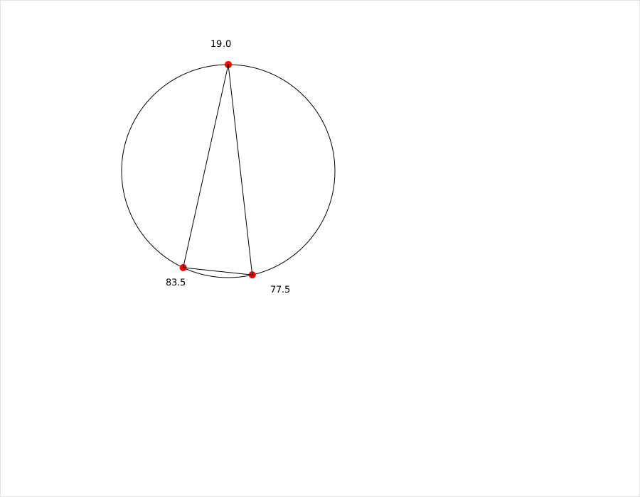
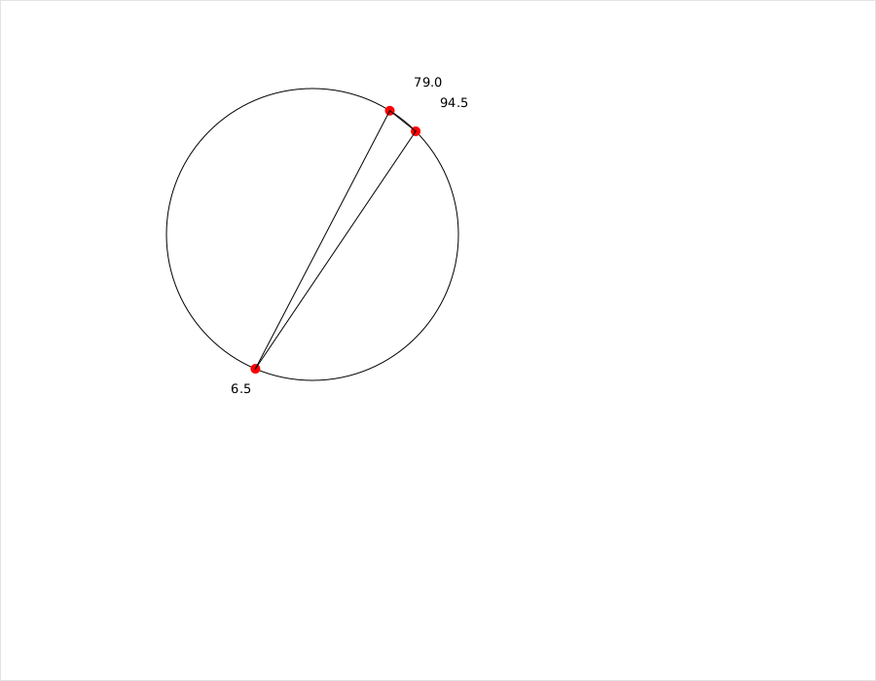
Question 4: Histogram

Problem Description:
Develop a program that displays a histogram to show the occurrences of each letter in a text area. The histogram should show the occurrences of each letter in a text file, as shown in the following figure. Assume that the letters are not case sensitive.

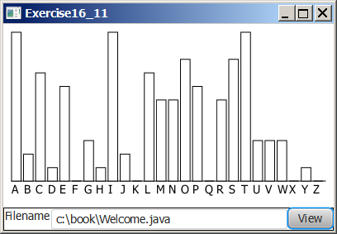

Your Task:
- Place a pane that will display the histogram in the center of the frame.
- Place a label and a text field in a panel, and put the panel in the south side of the frame. The text file will be entered from this text field.
- Pressing the Enter key on the text field causes the program to count the occurrences of each letter and display the count in a histogram.

Your Code: Copy-paste your code here:
package sample;
import javafx.scene.chart.XYChart;
import javafx.stage.Stage;
import javafx.application.Application;
import javafx.scene.Scene;
import javafx.scene.layout.HBox;
import javafx.scene.layout.Pane;
import javafx.scene.layout.VBox;
import javafx.scene.chart.CategoryAxis;
import javafx.scene.chart.NumberAxis;
import javafx.scene.chart.BarChart;
import javafx.scene.control.Button;
import javafx.scene.control.ContentDisplay;
import javafx.scene.control.Label;
import javafx.scene.control.TextField;
import java.io.BufferedReader;
import java.io.File;
import java.io.FileNotFoundException;
import java.io.FileReader;
import java.util.HashMap;
import java.util.regex.Pattern;
public class Main extends Application {
//Pane for graph
Pane pane = new Pane();
//Create bar chart
CategoryAxis xAxis = new CategoryAxis();
NumberAxis yAxis = new NumberAxis();
BarChart<String, Number> graph = new BarChart<>(xAxis, yAxis);
//File name text field & label
TextField textField = new TextField();
Label filenameLabel = new Label("Filename:", textField);
//Reader for file
BufferedReader reader;
//Store letter values and number of occurrences
HashMap<String, Integer> letterValues = new HashMap<>();
//View button
Button viewButton = new Button("View");
//Box for label, text field and button
HBox viewBox = new HBox(filenameLabel, viewButton);
@Override
public void start(Stage primaryStage) throws Exception {
//Root layout
VBox root = new VBox();
//Styling
graph.setCategoryGap(1);
graph.setBarGap(1);
filenameLabel.setContentDisplay(ContentDisplay.RIGHT);
//On click action for view button
viewButton.setOnAction(e-> {
try{
//Update the graph based on the file name
update();
}catch (java.io.FileNotFoundException f){}
});
root.getChildren().addAll(pane, viewBox);
Scene scene = new Scene(root);
primaryStage.setScene(scene);
primaryStage.show();
}
private void update() throws FileNotFoundException {
//Data for graph
XYChart.Series series = new XYChart.Series();
//Read file based on text field
File file = new File(textField.getText());
FileReader fileReader = new FileReader(file);
reader = new BufferedReader(fileReader);
//Read all characters and store all characters that belong to the file until no characters left
try {
while (reader.ready()){
char next = (char)reader.read();
if(!letterValues.containsKey(Character.toString(next).toUpperCase()) && Pattern.matches("[a-zA-z]", String.valueOf(next))){
letterValues.put(Character.toString(next).toUpperCase(), 1);
}else if(Pattern.matches("[a-zA-z]", String.valueOf(next))){
letterValues.put(Character.toString(next).toUpperCase(), letterValues.get(Character.toString(next).toUpperCase()) + 1);
}
}
}catch (java.io.IOException e){}
for(String item: letterValues.keySet()){
series.getData().add(new XYChart.Data(item, letterValues.get(item)));
}
pane.getChildren().removeAll(graph);
pane.getChildren().add(graph);
graph.getData().addAll(series);
}
public static void main(String[] args){launch(args);}
}
Screen shots: Include two screen shots here:
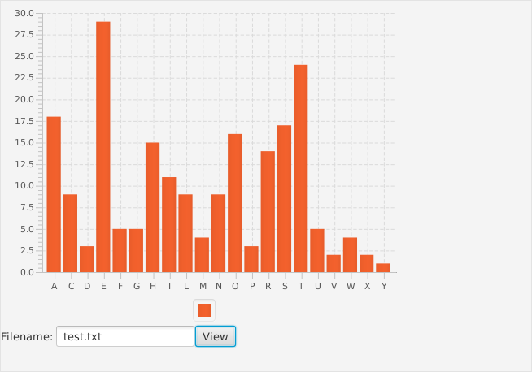
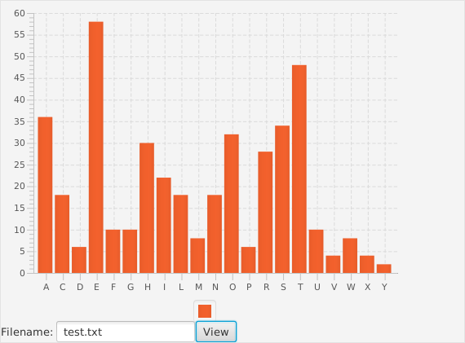
Remember:

You need to complete this file and submit it in related drop box on Blackboard, in addition to uploading your codes in your git repository, before deadline.

